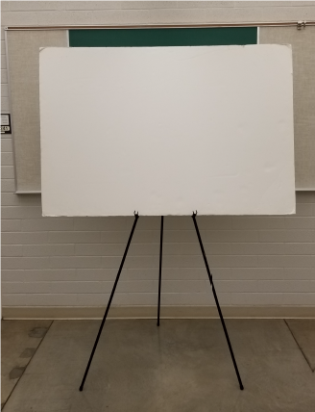

**40 inches**

**59.5 inches**

Easel will accommodate the poster board with either the 59.5 inch or 40 inch side horizontal.